Title of the paper

Sabine F. Author¹, …. Author²
¹Université de technologie de Compiègne, Laboratory Roberval, Compiègne, France
²Université…
sabine.author@utc.fr

Abstract - 200 words maximum

Keywords: System1, system2.

- Introduction
High precision … [1]. CMOS technology [2].

- Title of the second section
- Principle of the algorithm

- Pre-processing: Determination of the linear parts of reference signals

Each fiber (Fig. 1)…
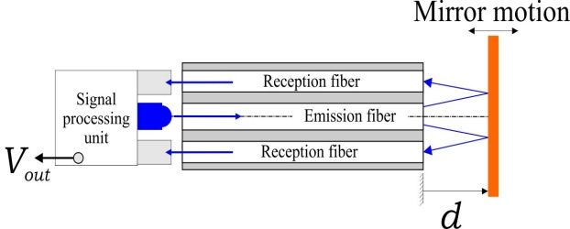
Figure 1. Fiber Optic Probe
Each result (Table I)

Table Head | Table Column Head
 | Table column subhead | Subhead | Subhead
copy | More table copyª

The system resolution can be obtained using the following formulas…
$a=b+2$ (1)

$f\left(x\right)=x+x$ (2)

- Conclusion and Perspectives
This sample paper presents the formatting instructions for the first international workshop Labex MS2T. Please address any problems related to use of this template to the Abstract Committee (Sabine BENSAMOUN, Frédéric LAMARQUE and Mohamed SALLAK).

Acknowledgment
The preferred spelling of the word “acknowledgment” in America is without an “e” after the “g”. Avoid the stilted expression “one of us (R. B. G.) thanks ...”. Instead, try “R. B. G. thanks...”. Put sponsor acknowledgments in the unnumbered footnote on the first page.

References
[1] K.K. Tan, Huixing X. Zhou and Tong Heng Lee, “New Interpolation Method for Quadrature Encoder Signals“, IEEE Trans. Instrum. Meas., vol. 51, no.5, pp. 1073-1079, Oct 2002

[2] J. Clerk Maxwell, A Treatise on Electricity and Magnetism, 3rd ed., vol. 2. Oxford: Clarendon, 1892, pp.68–73.

[3] Y. Yorozu, M. Hirano, K. Oka, and Y. Tagawa, “Electron spectroscopy studies on magneto-optical media and plastic substrate interface,” IEEE Transl. J. Magn. Japan, vol. 2, pp. 740–741, August 1987 [Digests 9th Annual Conf. Magnetics Japan, p. 301, 1982].

